**Requirements for execution of papers:**

• Length of the submitted paper – 1 – 2 pages (page format – A4);

• Text editor – «WORD for WINDOWS»;

• Font – Times New Roman, font size – 12;

• Line spacing – single;

• Margins: top, bottom, outside, inside – 2 cm;

• Figures should be inserted into the text of the paper (wrap text – top and bottom)

**Text layout**:

UDC – in the upper left corner (uppercase);

title of the report (font 12 bold in the center, all upper-case letters);

on the next line – full name of the authors;

then in one spacing – affiliation, below the city, country, e-mail of the author (font 12, in italics, in the center);

in one spacing abstract (5-6 lines), (font 12, in italics);

in one spacing keywords (5-10 words) (font 12, italics);

in two spacings the text of the paper (font 12).

UDC ……….

Title of the report (font 12 bold in the center, all upper-case letters)

Affiliation, below the city, country, e-mail of the author (font 12, in italics, in the center);

Abstract (5 – 6 lines).

keywords: word 1, word 2, …, word (5 – 7 word).

The text of the report is typed in Microsoft Word: A4 format, margins: upper 2 cm, lower 2 cm, left 2 cm, right 2 cm, text alignment, single line spacing, paragraph (automatic) - 1 cm, font Times New Roman, font size 12 pt, word hyphenation is automatic.

The maximum length of an abstract is 2 pages in English. Formulas should be indented on a separate line. When formulae are referred to in the text, they should be numbered with Arabic numerals (1) at the right-hand edge of the page in parentheses.

 (1)

If there is only one figure and/or one table in the text, they are not numbered.

Table 2 –

|  |  |  |  |  |  |  |  |  |  |  |
| --- | --- | --- | --- | --- | --- | --- | --- | --- | --- | --- |
| Область | Al | Si | Mg | Ti | Fe | Ni | Cu | Y | О | С |
| 1 | 47,2 | 3,0 | 0,6 | 1,0 | 0,7 | 1,3 | 1,8 | 16,2 | 10,8 | 17,4 |
| 2 | 0,8 | 0,0 | 0,0 | 0,2 | 0,7 | 0,5 | 0,7 | 34,0 | 28,1 | 35,0 |

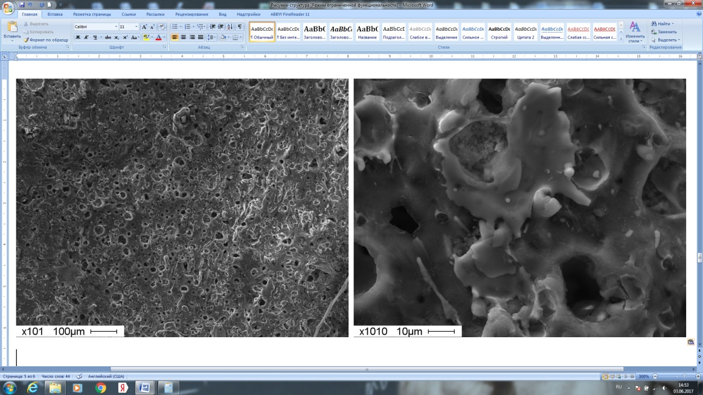 

Figure 1(font 12) –

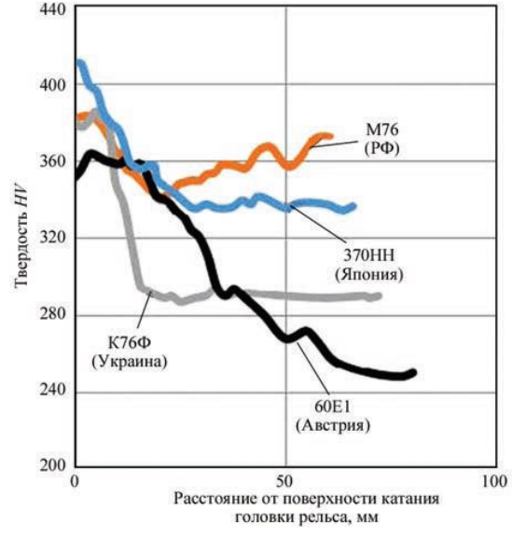

Figure 2 (font 12) –

*Acknowledgements, if any, are indented after the text and printed in italics.*

**REFERENCES**

1. Friedlander I. N. Aluminium alloys. Deformable alloys / I. N. Friedlander. M.: Mashinostroenie, 1964. 224 c. (book, one author).

2. Goldstein M. I. Special steels: textbook / M. I. Goldstein, S. V. Grachev, Y. G. Veksler. M.: MISS, 1999. 408 с. (book, not more than three authors)

3. Corrosion-resistant, heat-resistant and high-strength alloys: a handbook / A.P. Shlyamnev [et al]. Moscow: Internet Engineering, 2000. 232 с. (book, more than three authors)

4. Veselov, A.A. Determination of pipe end dimensions after distribution by plastic deformation / A.A. Veselov // Morskaya Vestnik. 2012. № 1. С. 15-16. (article, up to three authors)

5. Davydov V. G. Peculiarities of solid solution decomposition of D16 alloys at hardening cooling with secondary heating / V. G. Davydov [et al] // MiTOM. 1993. № 6. С. 3-6. (article, more than three authors)

6. Ivanov I. I. Research Methods: Ph. Candidate of Technical Sciences. / I. I. Ivanov. MOSCOW: MISIS, 2002. 129 с. (dissertation).

7. Petrov P. P. Prediction Methods: Autoref. dis. D. in Technical Sciences. / P. P. Petrov. Ekaterinburg: UGTU-UPI, 2005. 27 с. (abstract).

8. Transmitting-receiving device: Pat. 2187888 Russian Federation. Federation: IPC H 04 V 1/38, H 04 J 13/00 / V.I. Chugaeva; applicant and patent holder - Voronezh scientific-research communications institute. ¹ 2000131736/09; Application form. 18.12.00; publ. 20.08.02, Bulletin #23 (II part). 3 с. (patent)

9. GOST R 51685-2013. Rail rails. General specifications. - Introduced on 01.07.2014. - Moscow : Standardinform, 2014. - 101 с.

10. ANSINACEMRISO Petroleum and gas industry. Materials for use in environments containing hydrogen sulphide in the extraction of oil and gas. Part 3: Corrosion-resistant alloys (CRAs) and other anti-cracking alloys. 2010. 80 с.